**Section 10.1 Cell Growth, Division & Reproduction**

*Use the information in Chapter 10 (p.274-278) to answer the following questions. Bozeman also has a nice podcast that could help you review, called* [*Why Are Cells Small?*](http://www.bozemanscience.com/why-are-cells-small)

1. **Discuss** the three major problems that a cell faces as they become larger:

* Information “Overload”

* Exchanging Materials
* “Traffic” Problems

1. **Calculate** the surface area, volume and surface area-to-volume ratio for the following model cells.

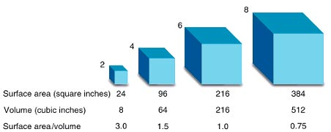

|  |  |  |  |  |
| --- | --- | --- | --- | --- |
|  | 2x2x2 | 4x4x4 | 6x6x6 | 8x8x8 |
| Surface Area |  |  |  |  |
| Volume |  |  |  |  |
| SA/V Ratio |  |  |  |  |

SHOW ALL WORK FOR ONE OF THE CUBES ABOVE:

1. **Explain** how cell division solves the problems of a cell becoming too large?
2. Complete the following table in which you thoroughly **compare** **and contrast** sexual and asexual reproduction.

|  |  |  |
| --- | --- | --- |
| **Sexual Reproduction** | **Both** | **Asexual Reproduction** |
|  |  |  |

**Section 10.2 The Process of Cell Division**

*Use the information in Chapter 10 (p.279-286) to answer the following questions. Bozeman also has podcasts that can help:* [*DNA & RNA Part I*](http://www.bozemanscience.com/027-part-1-dna-rna) *and* [*The Cell Cycle*](http://www.bozemanscience.com/mitosis)*.*

1. **Explain** how prokaryotic chromosomes compare and contrast to eukaryotic chromosomes.
2. **Label** the structures below and discuss how DNA is packaged into structures known as chromosomes.

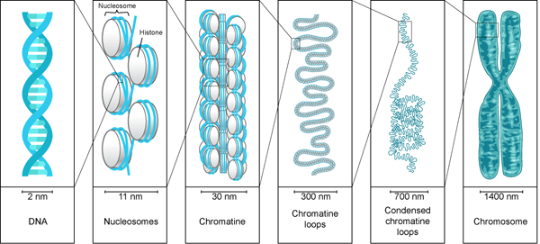

1. **Discuss** the steps involved in binary fission for a prokaryotic cell. Draw a diagram to help your explanation.
2. Complete the following table in which you **describe** the events of the cell cycle.

|  |  |  |
| --- | --- | --- |
| **Phase** | **Events Inside Cell** | **Diagram** |
| INTERPHASE (G1 Phase) |  | ------------------------------------- |
| INTERPHASE (S Phase) |  | ------------------------------------- |
| INTERPHASE (G2 Phase) |  | ------------------------------------- |
| MITOSIS (Prophase) |  |  |
| MITOSIS (Metaphase) |  |  |
| MITOSIS (Anaphase) |  |  |
| MITOSIS (Telophase) |  |  |
| CYOTKINESIS | \**Include BOTH plant and animal cells* |  |